Chapter 4, Solution 84

Let the equivalent circuit of the battery terminated by a load be as shown below.

R_{Th}

I_{L}
+ +
V_{Th}
₋ V_{L} R_{L}
₋

For open circuit,

When R_{L} = 4 ohm, V_{L}=10.5,

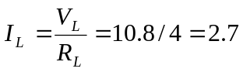
But
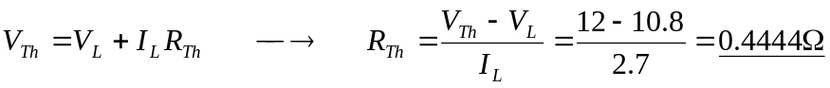

= 444.4 mΩ.

